**Signal processing and biomarkers for state transition classification by LDA method**

**Preprocessing and visualization of EMF\CGM signal**

We apply the following pipeline to preprocess the initial EMF (considered as bio-magnetic) signal.

**1. Data Acquisition & Import**

- Source: TDMS files containing multivariate time series from magnetic sensors – 10 T1D patients (“Insulin Clamp”) and 10 healthy patients (“Normal”) – recorded over several hours each, within the protocol.  
- Channels: Multiple sensor locations (Head_left/right, Hand1/2, Liver1/2, Background1/2)  
- Metadata and Labels: Glucose-related and additional labels and glucose measurements from the combined Excel file  
- Time Correction: Adjusting timestamps using GMT+2 correction

**2. Signal Conditioning**

- Downsampling: Signal decimation (averaging) from 5000 Hz (original) to 250Hz  
- Noise Detection: Automated identification of power line interference (50 Hz, higher harmonics and sub-harmonics)  
- Bandpass Filtering:

* Low cutoff: 0.05 Hz (preserves very slow Delta1 oscillations)
* High cutoff: 40 Hz
* Order: 6 (for steeper roll-off)

- Baseline Correction: Removing baseline drift  
- Artifact Handling:

* Detecting saturation events (>245 nT amplitude)
* Identifying anomalous segments using variance and derivative thresholds
* Interpolating corrupted segments

**3. Signal Enhancement**

- Paired Channel Processing: Combining paired channels (left/right) for each sensor location  
- Correlation Analysis: Calculating rolling correlation between channel pairs

* Window size: 5000 samples
* Correlation threshold: 0.3

- Signal Cleaning: Interpolating segments with poor inter-channel correlation

4. **Saving the Output Data**

- Preprocessed signal is saved within the Parquet files format for next step analysis

**Visualizations, PSD and glycemic transitions**

We have performed multiple sets of visualizations for the extracted signal and it’s PSD components for all the patients and channels.

All the visualizations of high quality might be found in the corresponding folders. Here is an example for the visualizations for T1D patient #1 (“Insulin Clamp #1”)

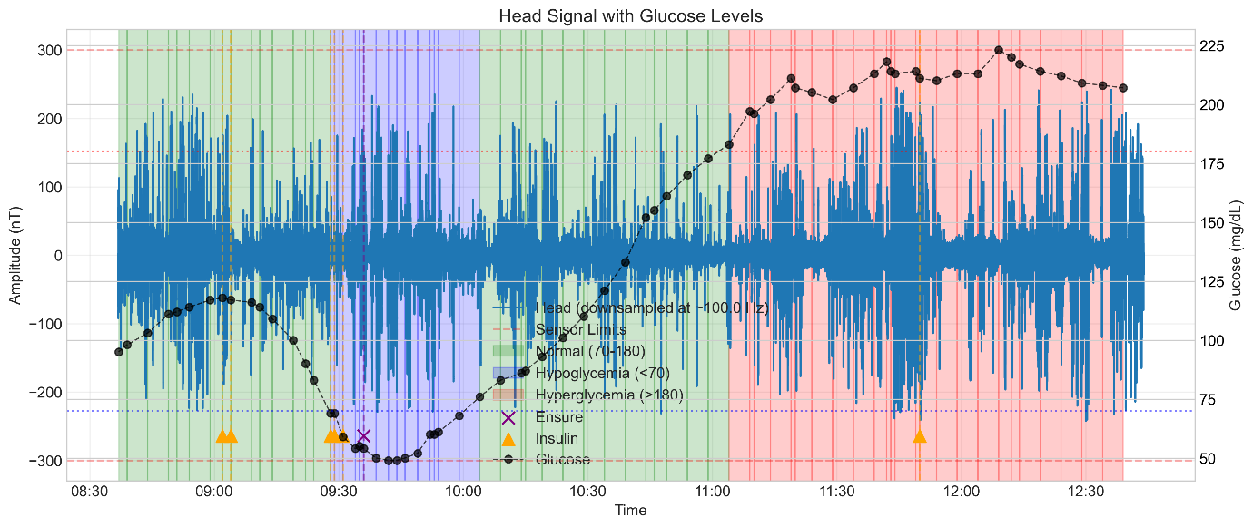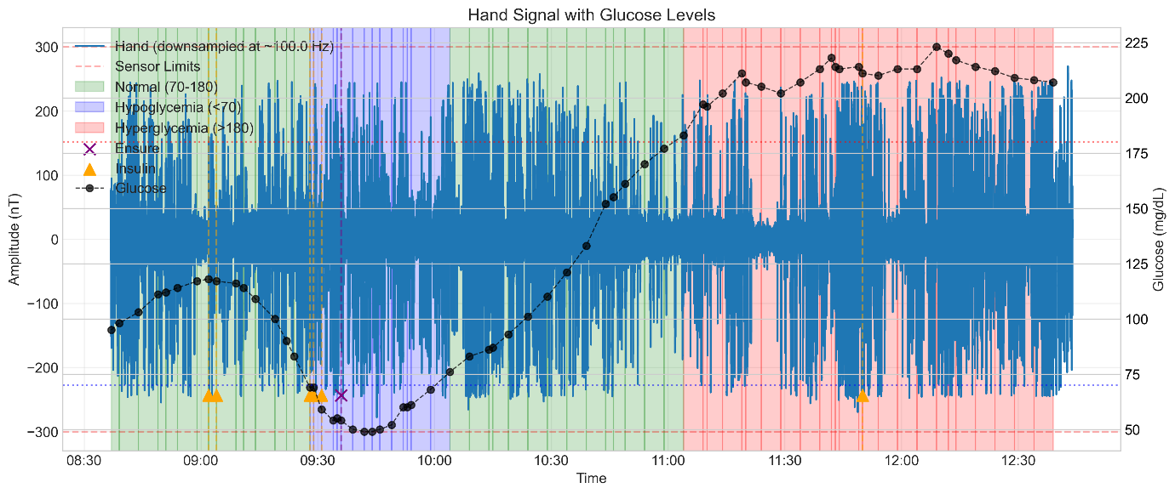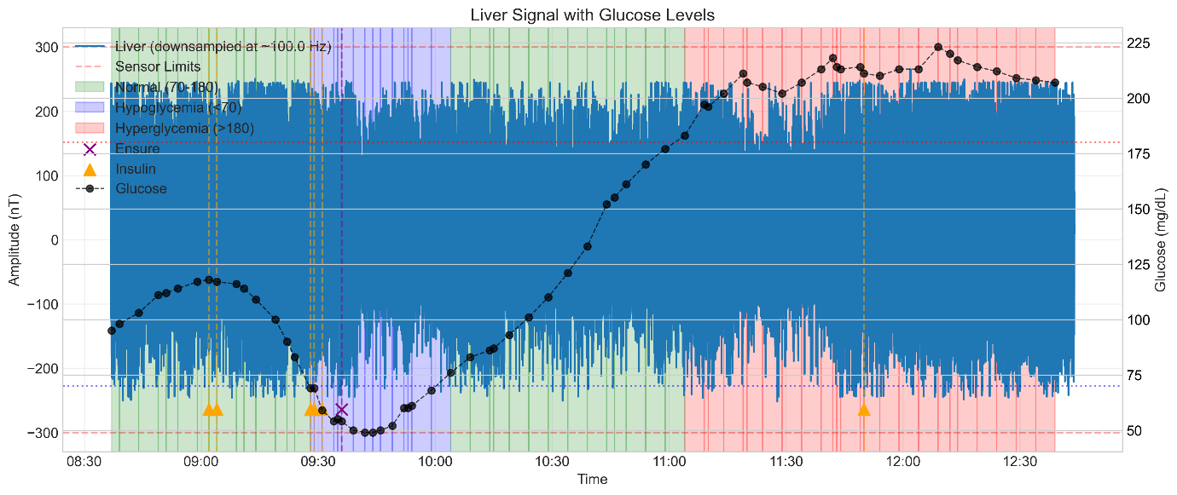

Next step of visualization is a PSD charts with event-synchronized labeling.  
Power spectrum signature and it’s derivatives over time are a potential signal features, that might be an important biomarker for glycemic and metabolic states.

On the figures above the differences are in the marked regions

The following charts are an additional time-domain visualization with additional low-pass filtering (emphasizing the slowly varying signal) and glucose (CGM) and modelled insulin concentration overlays.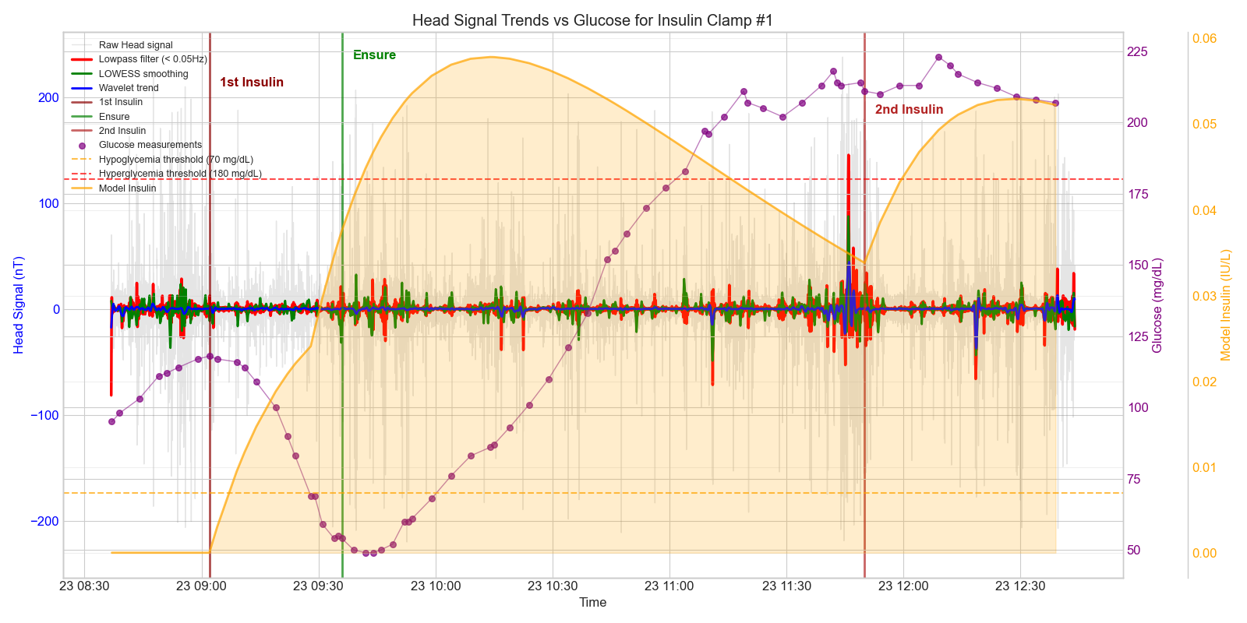  
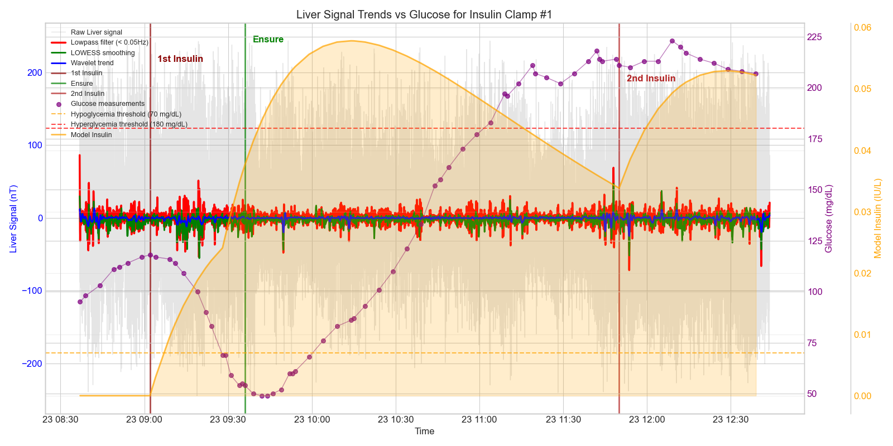

The insulin concentration is an approximation that has been constructed based on insulin pharmacodynamics, relevant to the selection of insulin type and on the known injection records for every T1D patient. (Important note – it is a reconstruction, not a measurement)  
These charts are intended to visually evaluate any signs of global trends (AC coupled sensor) and possible signal patterns, potentially related to the metabolic/glycemic events  
Hi-resolution versions of these charts are available for every patient.

**Glycemic and Metabolic Transitions by LDA analysis**

Potential EMF signal transitions (by means of signal feature changes) could be indicative of specific physiological events in diabetic patients.  
- Insulin administration  
- Ensure intake (glucose supplement)  
- Hypoglycemic episodes  
- Hyperglycemic episodes

Ensure/Insulin: Expected to induce relatively short-term, rapid signal changes, suitable for anomaly detection or transient feature tracking.  
Hypo/Hyper: Expected to relate to longer-term changes, warranting analysis over broader time windows.

While looking at some specific biomarkers to distinguish between the “before” and “after” states for Glycemic and Metabolic transitions, one of the supportive results have been related to the LDA analysis

LDA (Linear Discriminant Analysis) is an event-related feature clustering in low-dimension space, been performed over the individual patients (possible individual variability in signal response patterns)

This method:

- Projects feature space to maximize separability between "before"/"after" states  
- Identifies most discriminative features  
- Visualizes class separation via LDA projection plots: Density distribution of "before"/"after" samples in LDA space  
- Visualizes Confusion Matrices for classification evaluation of state separation  
- Evaluates classification performance  
- Reports feature importance rankings

On the following charts (LDA visualizations) one can see the Embedding Projections of the feature space, emphasizing the potential Event Clustering in LDA space with appropriate distributions "before" and "after" the event.

From these charts one can clearly see that while the glycemic transitions are gradual (like 2nd order transitions), the metabolic transitions are linearly separable (like 1st order transitions)

This introspection agrees with the expected behavior of glycemic (gradual) and metabolic (instant) state transitions and could be taken as a weak proof for the state separability by EMF signal features.

**Metabolic - First Insulin:**

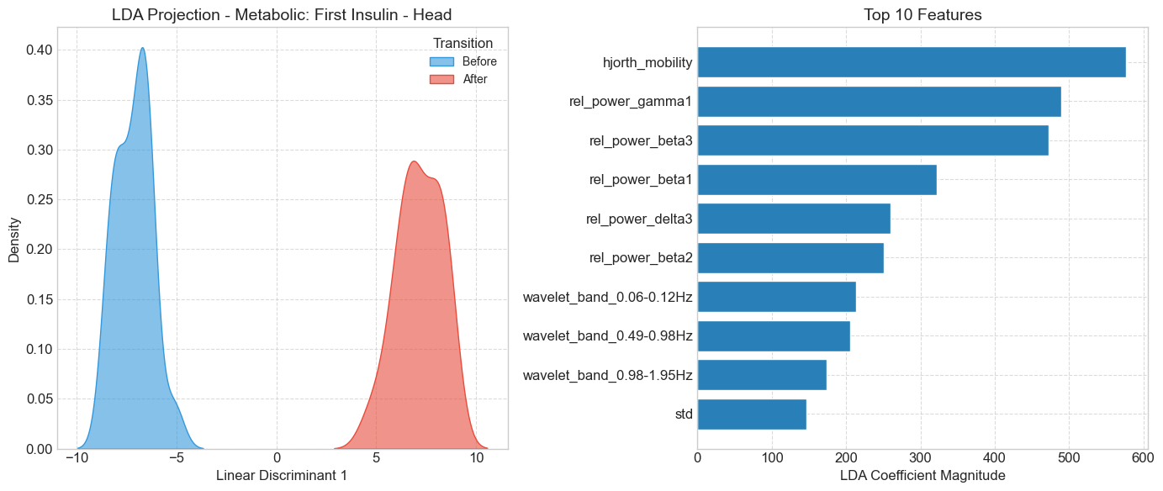

**Metabolic – Ensure:**

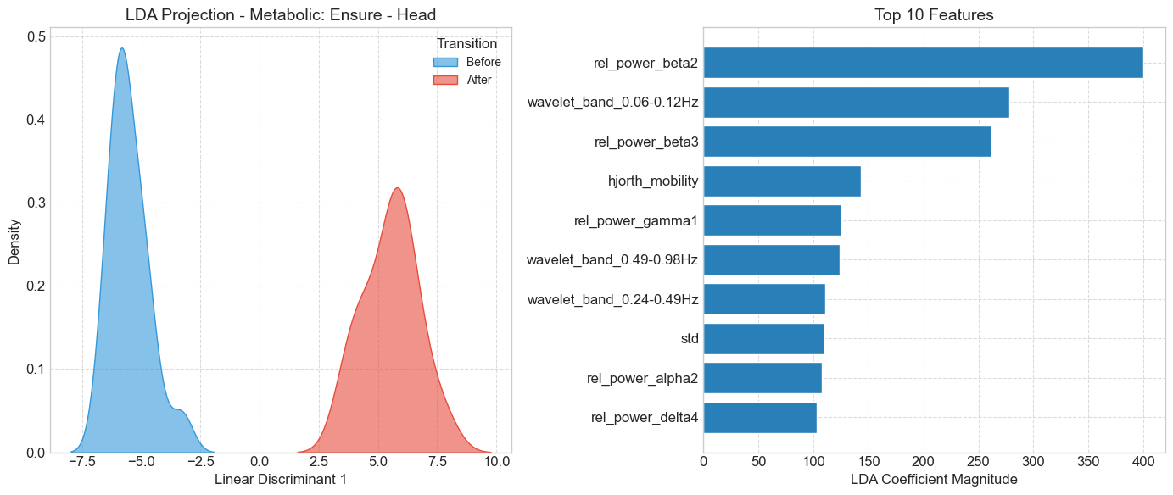

**Metabolic – Second Insulin:**

Glycemic – Normal-to-Hypoglycemia:

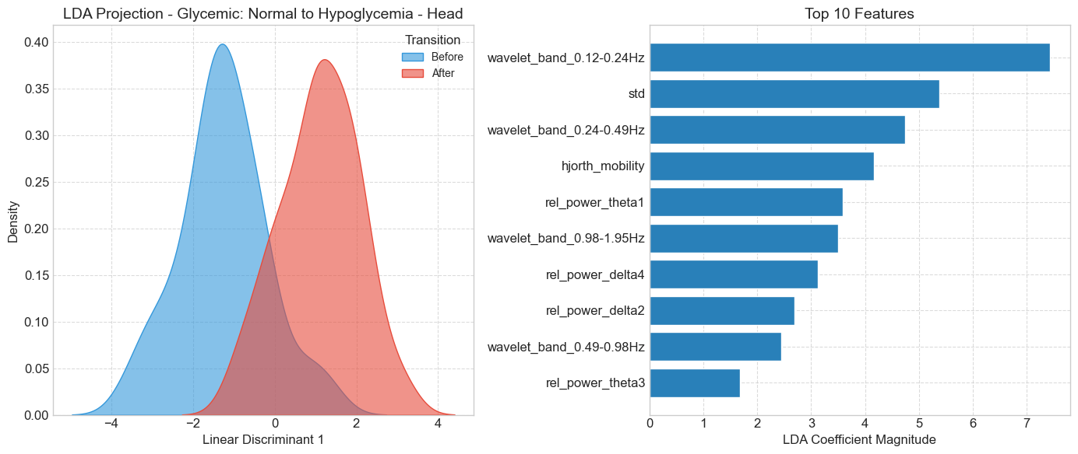

Glycemic - Normal-to-Hyperglycemia:

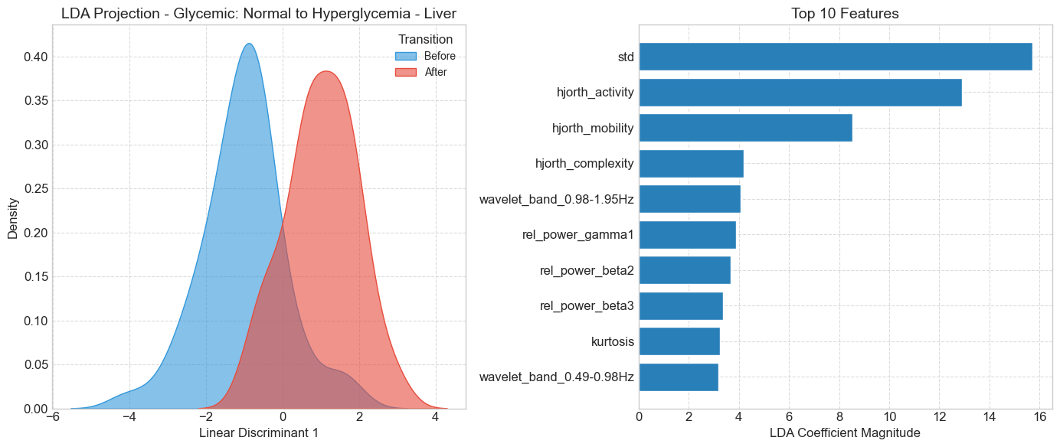

Glycemic - Hypoglycemia-to-Normal:

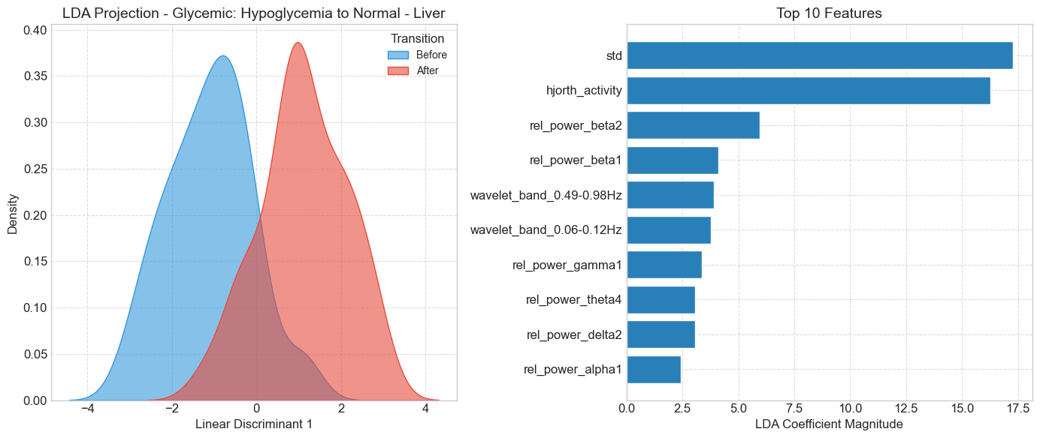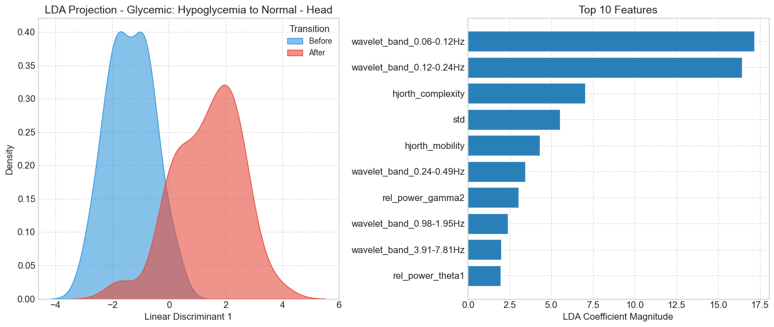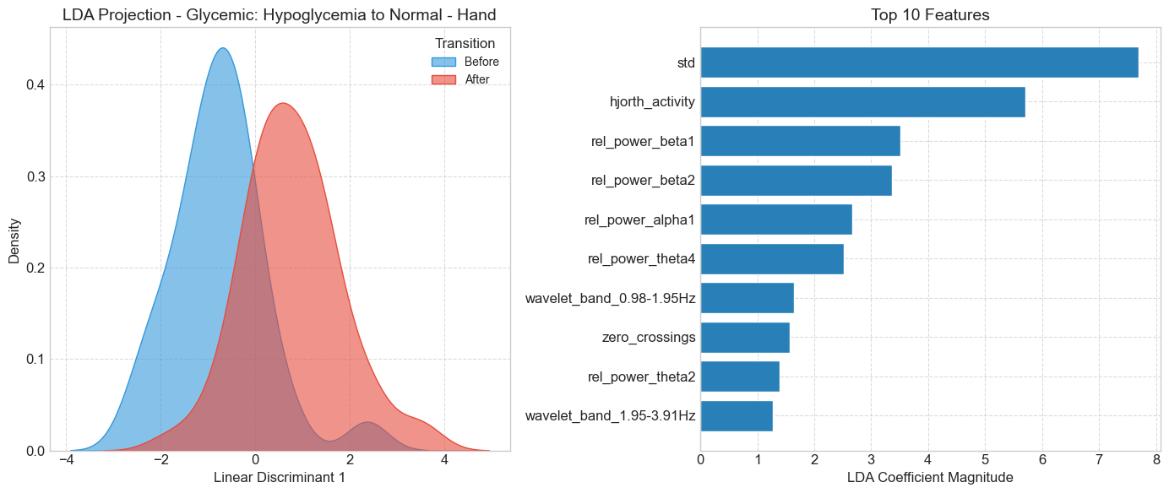

Here is the LDA analysis classification report for state transitions

* Statistical and Hjorth metrics of the signal are amongst the top discriminative features.  
  Beta band wavelet features (or relative powers) – 13-30Hz are amongst the secondary top discriminative features.
* For Metabolic Transitions we are getting very high LDA scores for most of the features (highly separable)
* “Second Insulin” transition has a lower score, being a kind of mixed state.

Hypoglycemia to Normal – Hand top 10 discriminative features:

**1. std: 7.6966**

**2. Hjorth activity: 5.7095**

3. rel. power_beta1: 3.5166

4. rel. power_beta2: 3.3666

5. rel. power_alpha1: 2.6655

6. rel. power_theta4: 2.5212

7. wavelet_band_0.98-1.95Hz: 1.6386

8. zero crossings: 1.5669

9. rel. power_theta2: 1.3929

10. wavelet_band_1.95-3.91Hz: 1.2728

Hypoglycemia to Normal – Head top 10 discriminative features:

**1. wavelet band 0.06-0.12Hz: 17.1798**

**2. wavelet band 0.12-0.24Hz: 16.4429**

**3. Hjorth complexity: 7.0469**

**4. std: 5.5322**

5. Hjorth mobility: 4.3306

6. wavelet band 0.24-0.49Hz: 3.4535

7. rel. power gamma2: 3.0495

8. wavelet band_0.98-1.95Hz: 2.3959

9. wavelet band 3.91-7.81Hz: 2.0035

10. rel. power theta1: 1.9669

Hypoglycemia to Normal – Liver top 10 discriminative features:

**1. std: 17.2887**

**2. Hjorth activity: 16.2601**

**3. rel. power beta2: 5.9473**

4. rel. power beta1: 4.1062

5. wavelet band 0.49-0.98Hz: 3.9196

6. wavelet band_0.06-0.12Hz: 3.7741

7. rel. power gamma1: 3.3566

8. rel. power theta4: 3.0702

9. rel. power delta2: 3.0592

10. rel. power alpha1: 2.4111

Normal to Hyperglycemia – Hand top 10 discriminative features:

**1. rel. power_beta2: 5.5192**

**2. Hjorth activity: 4.2734**

3. rel. power beta1: 3.1304

4. Shannon entropy: 3.0537

5. rel. power theta4: 2.6938

6. rel. power delta2: 2.4943

7. rel. power delta1_3: 2.2066

8. Hjorth mobility: 1.8165

9. rel. power beta3: 1.7628

10. wavelet band 1.95-3.91Hz: 1.6414

Normal to Hyperglycemia – Head top 10 discriminative features:

**1. std: 5.8137**

2. wavelet band 0.06-0.12Hz: 4.3517

3. Hjorth mobility: 3.2500

4. rel. power beta3: 2.7101

5. Hjorth activity: 2.2486

6. kurtosis: 1.7637

7. rel. power theta4: 1.6755

8. wavelet band 0.98-1.95Hz: 1.6037

9. rel. power theta2: 1.5429

10. rel. power theta3: 1.4555

Normal to Hyperglycemia – Liver top 10 discriminative features:

**1. std: 15.7218**

**2. Hjorth activity: 12.9016**

**3. Hjorth mobility: 8.5339**

4. Hjorth complexity: 4.1874

5. wavelet band 0.98-1.95Hz: 4.0687

6. rel. power gamma1: 3.8957

7. rel. power beta2: 3.6679

8. rel. power beta3: 3.3574

9. kurtosis: 3.2491

10. wavelet_band_0.49-0.98Hz: 3.1725

Normal to Hypoglycemia – Hand Top 10 discriminative features:

1. rel. power beta3: 4.0721

2. Hjorth activity: 3.2676

3. rel. power theta1: 2.9353

4. rel. power delta3: 2.6995

5. Hjorth mobility: 2.2449

6. rel. power beta2: 1.8344

7. rel. power alpha1: 1.8287

8. std: 1.7823

9. Hjorth complexity: 1.3821

10. rel. power beta1: 1.0623

Normal to Hypoglycemia – Head top 10 discriminative features:

**1. wavelet band 0.12-0.24Hz: 7.4342**

**2. std: 5.3744**

3. wavelet band 0.24-0.49Hz: 4.7417

4. Hjorth mobility: 4.1648

5. rel. power theta1: 3.5908

6. wavelet band 0.98-1.95Hz: 3.5017

7. rel. power delta4: 3.1205

8. rel. power delta2: 2.6965

9. wavelet band 0.49-0.98Hz: 2.4445

10. rel. power theta3: 1.6795

Normal to Hypoglycemia – Liver top 10 discriminative features:

**1. Hjorth activity: 7.2753**

**2. std: 6.3336**

3. Hjorth mobility: 4.8791

4. rel. power_beta3: 2.3815

5. wavelet band 0.06-0.12Hz: 1.9053

6. wavelet band 3.91-7.81Hz: 1.8775

7. rel. power_beta1: 1.5813

8. kurtosis: 1.5523

9. Shannon entropy: 1.5385

10. wavelet band 0.49-0.98Hz: 1.3481

Ensure – Hand top 10 discriminative features:

1. rel. power gamma1: 212.6717

2. rel. power beta2: 192.8418

3. wavelet band 1.95-3.91Hz: 171.5789

4. Hjorth activity: 150.8640

5. rel. power theta3: 120.7304

6. std: 112.8101

7. Shannon entropy: 103.4356

8. wavelet band 0.49-0.98Hz: 99.8254

9. rel. power theta2: 97.9700

10. Hjorth mobility: 86.4376

Ensure – Head top 10 discriminative features:

1. rel. power beta2: 399.8337

2. wavelet band 0.06-0.12Hz: 278.0747

3. rel. power beta3: 262.0162

4. Hjorth mobility: 143.4105

5. rel. power gamma1: 125.4366

6. wavelet band 0.49-0.98Hz: 124.2649

7. wavelet band 0.24-0.49Hz: 110.8668

8. std: 110.1162

9. rel. power alpha2: 107.5917

10. rel. power delta4: 103.0151

Ensure – Liver top 10 discriminative features:

1. std: 436.6105

2. Hjorth mobility: 433.7537

3. Hjorth activity: 206.7610

4. rel. power beta2: 137.6256

5. Hjorth complexity: 131.7586

6. wavelet band 3.91-7.81Hz: 108.6800

7. rel. power theta2: 91.0827

8. wavelet band 1.95-3.91Hz: 87.8593

9. rel. power theta3: 87.5118

10. wavelet band 0.24-0.49Hz: 87.3614

First Insulin – Hand top 10 discriminative features:

1. rel. power gamma1: 372.5153

2. rel. power gamma2: 160.2246

3. Hjorth complexity: 129.8969

4. Hjorth activity: 125.1139

5. wavelet band 0.24-0.49Hz: 105.1308

6. std: 99.7830

7. Hjorth mobility: 96.3248

8. rel. power beta3: 86.4899

9. zero crossings: 76.5386

10. wavelet band 0.06-0.12Hz: 65.3726

First Insulin – Head top 10 discriminative features:

1. Hjorth mobility: 577.1398

2. rel. power gamma1: 489.7650

3. rel. power beta3: 472.0421

4. rel. power beta1: 321.5795

5. rel. power delta3: 259.8390

6. rel. power beta2: 250.4212

7. wavelet band 0.06-0.12Hz: 213.4250

8. wavelet band 0.49-0.98Hz: 205.7194

9. wavelet band 0.98-1.95Hz: 174.2662

10. std: 146.5318

First Insulin – Liver top 10 discriminative features:

1. std: 278.1489

2. Hjorth activity: 258.9070

3. wavelet band 0.98-1.95Hz: 196.4086

4. Hjorth complexity: 147.5469

5. Hjorth mobility: 132.6737

6. wavelet band 3.91-7.81Hz: 109.7279

7. rel. power theta2: 84.3235

8. rel. power delta1 3: 73.2608

9. rel. power beta1: 61.1631

10. rel. power delta4: 59.5806

Second Insulin – Hand top 10 discriminative features:

1. std: 94.1614

2. rel. power beta3: 71.6781

3. rel. power beta2: 63.1558

4. Hjorth mobility: 53.6668

5. rel. power beta1: 53.6218

6. zero crossings: 52.5931

7. rel. power theta2: 52.5466

8. rel. power alpha1: 51.5042

9. rel. power alpha2: 38.0100

10. rel. power theta1: 36.2919

Second Insulin – Head top 10 discriminative features:

1. rel. power gamma1: 138.8035

2. wavelet band 0.49-0.98Hz: 102.8426

3. Hjorth mobility: 100.1445

4. wavelet band 7.81-15.62Hz: 96.0510

5. wavelet band 1.95-3.91Hz: 92.8529

6. wavelet band 0.06-0.12Hz: 83.5795

7. rel. power alpha2: 76.9634

8. wavelet band 0.98-1.95Hz: 58.8732

9. std: 50.3959

10. zero crossings: 48.9871

Second Insulin – Liver top 10 discriminative features:

1. std: 808.6887

2. Hjorth activity: 648.3891

3. rel. power alpha2: 494.9265

4. rel. power alpha1: 309.5930

5. rel. power beta1: 263.0532

6. rel. power beta3: 132.3348

7. rel. power beta2: 117.7946

8. Hjorth mobility: 103.2628

9. wavelet band 3.91-7.81Hz: 96.2111

10. rel. power delta1 3: 87.2845

It is important to mention that the LDA analysis is performed on a single patient at a time due to anticipated individual variability and poor generalization. LDA only analyzes static feature differences, not considering highly complex temporal dynamics.

High separability of the classes on a single patient **shall be taken with caution** (potential overfitting) and can serve as a supportive claim only.